Project Documentation

- Introduction
- Project title: AI Study Buddy
- Team ID:
- Team Leader: Rathi Priya P (24csrathipriya.p77@gmail.com)
- Team Members:
- Rathika K (24csrathika076@gmail.com)
- Reena M (24csreena.m78@gmail.com)
- Rithika V (24csrithika.v79@gmail.com)
- Rohita P (24csrohita080@gmail.com)

- Project overview
AI Study Buddy is an intelligent educational application designed to help students learn, revise, and manage their studies effectively. It uses Artificial Intelligence (AI) to provide personalized learning support based on the student’s needs.

Key features include:

- AI-based question answering
- Study material management
- Topic explanations and summaries
- Quiz and practice questions
- Personalized learning support
- Easy-to-use interface
- Quick access to educational resources

- Architecture
The AI Study Buddy follows a client–server architecture where
user interacts with the application through the frontend, while
. the backend processes requests and communicates with the AI
model and database.
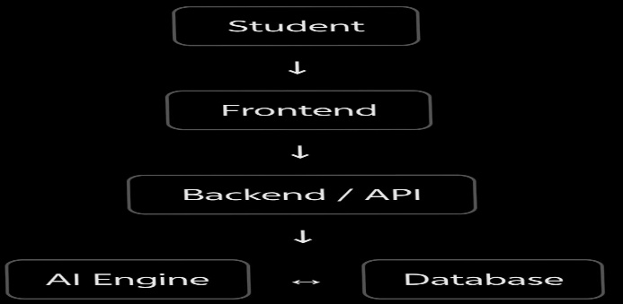

- System Requirements

Hardware Requirements
- Processor: Intel Core i3 or above
- RAM: Minimum 4 GB
- Storage: Minimum 10 GB free space
- Display: 1366 × 768 resolution or above
- Internet: Stable internet connection for AI services
Software Requirements
- Operating System: Windows 10/11 or Linux
- Frontend: HTML, CSS, JavaScript
- Backend: Python / Java (as used in the project)
- Database: MySQL / MongoDB
- AI Service: AI/LLM API

- Technology Stack
Node.js – Used as the runtime environment for executing the backend code.
Express.js – Used to develop the backend server and API routes.
MongoDB – Used to store user and study-related data.
Google Gemini API – Used to provide AI-based responses and study assistance.
JWT Authentication – Used to authenticate users and protect secured API endpoints.

- Modules description
- User Authentication Module → Login/Register or authentication-related code screenshot
- Authentication Middleware Module → Authentication middleware
- Study Material Upload Module → POST /api/material/upload
- AI Study Assistance Module → Gemini API-related
- Material Management Module → Material-related API

- System Workflow
The AI Study Buddy system follows a structured workflow to provide secure and AI-based study assistance to students.
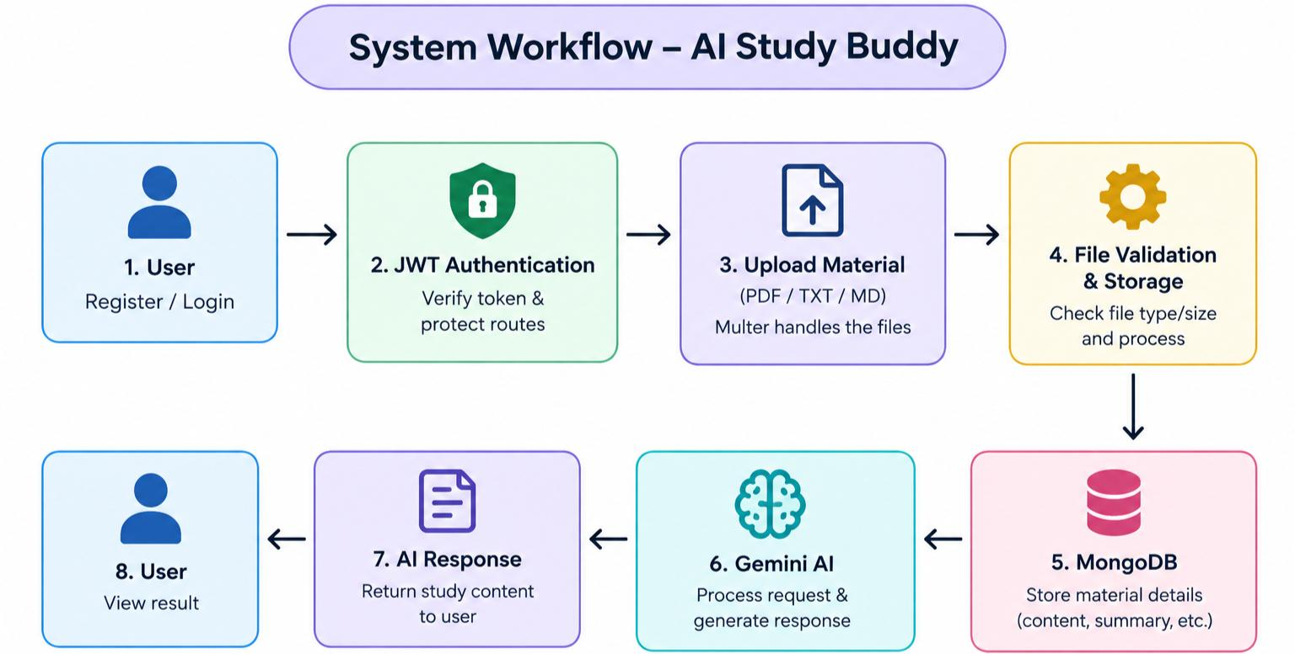

Module Description

The AI Study Buddy project is divided into different modules to organize the major functions of the application. Each module performs a specific task and works together to provide a complete and user-friendly study platform.

1. User Authentication Module

This module manages user registration and authentication. Users can create an account and log in using their credentials. Authentication helps protect user information and ensures that only authorized users can access protected features.

2. Study Material Module

This module is used to manage study materials. Users can upload and access relevant learning resources. The backend provides APIs to handle material uploading and storage, making study resources easier to organize and access.

3. Admin Module

The Admin Module provides administrative functions for managing the application. The administrator can monitor users and study materials and perform necessary management operations. This module helps maintain the proper functioning of the system.

4. AI Study Assistance Module

This module provides AI-based assistance to support the learning process. It can be used to help students understand study-related content and obtain useful responses based on their learning requirements.

5. Database Management Module

This module manages the storage and retrieval of application data. User information and study-material details are maintained in the database, allowing the system to access the required information efficiently

Database Design
The AI Study Buddy project uses MongoDB as its database. Mongoose is used to define
schemas and interact with MongoDB.

User collection

Field | Description
Name | Name of the user
Email | Users email address
Password | Hashed user password
Role | Student or admin

Material collection

Field | Description
User | Reference to the user
Title | Title of study material
Content | Study material content
Filename | Uploaded file name
Summary | AI-generated summary
Flashcards | Questions and answers for  revision
Quizz | Generated study plan
Studyplan | Created and updated time

Data base relationship

The AI Study Buddy project uses a relationship between the User and Material collections in MongoDB.
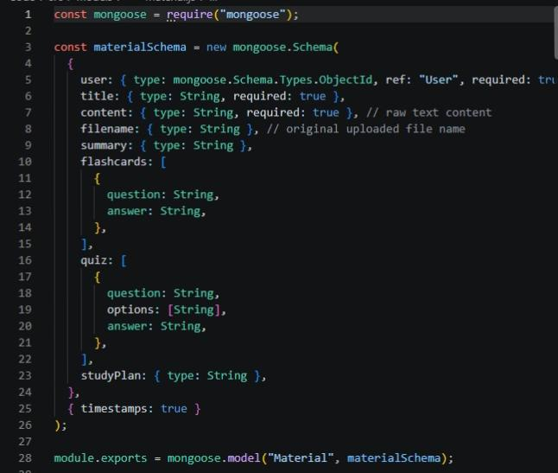
- A User can have multiple study materials.
- Each Material belongs to one specific User.
- This forms a One-to-Many (1:N) relationship.
- The relationship is created using the User ObjectId reference in the Material schema.
- The Material collection stores the study materials and AI-generated study content.

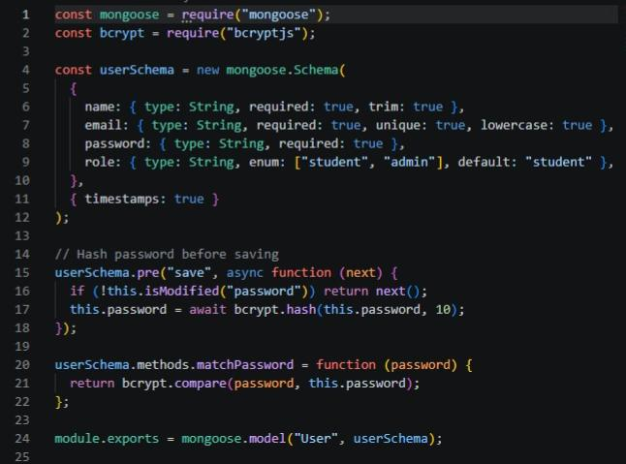

- Implementation
The AI Study Buddy project is implemented using a Node.js and Express.js backend
. with MongoDB for data storage and Google Gemini API for AI-based study
assistance.

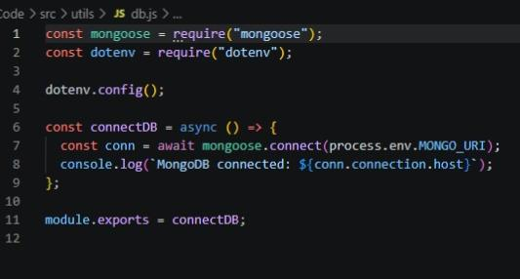
Implementation Process
- Backend Setup
Node.js and Express.js are used to create the backend server and API endpoints.
- Database Implementation
MongoDB is connected using Mongoose. The User and Material schemas are
created to store user and study-material details.
- User Authentication
User registration and login are implemented using bcrypt for password hashing and
JWT for secure authentication.
- File Upload
Multer is used to upload and validate study materials such as PDF, TXT, and MD
files.
- AI Integration
Google Gemini API is integrated to generate AI-based study assistance such as
Summaries,flashcards, quizzes, and study plans.
- API Integration
The different modules are connected through REST API routes, allowing the
. application to communicate with the backend securely.
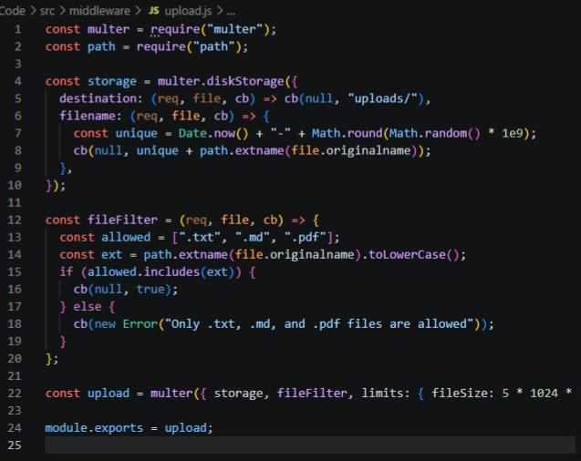

Authentication and Authorization Middleware
The auth.js middleware is used to provide secure authentication and authorization in the AI Study Buddy application. It verifies the JWT token sent by the user and allows access only to authenticated users. It also includes an admin-only authorization function to restrict certain operations to administrators. This helps protect the application’s APIs and user data from unauthorized access.
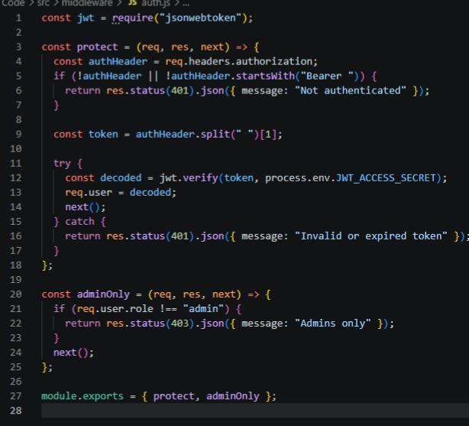

Google Gemini AI Integration
The gemini.js module integrates Google Gemini AI into the AI Study Buddy application. It connects to the Gemini API using an API key and initializes the selected Gemini model. The askGemini() function sends user prompts to the AI and returns the generated response. This integration enables AI-based features such as summarization, study-plan generation, quizzes, and flashcardmps
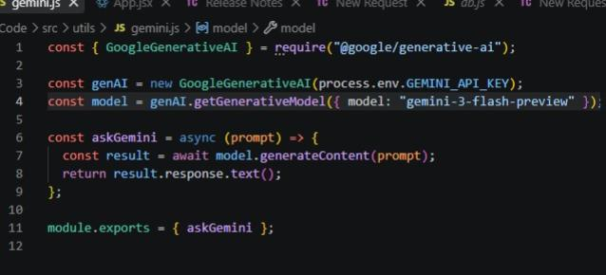

Backend Server Configuration using Express.js
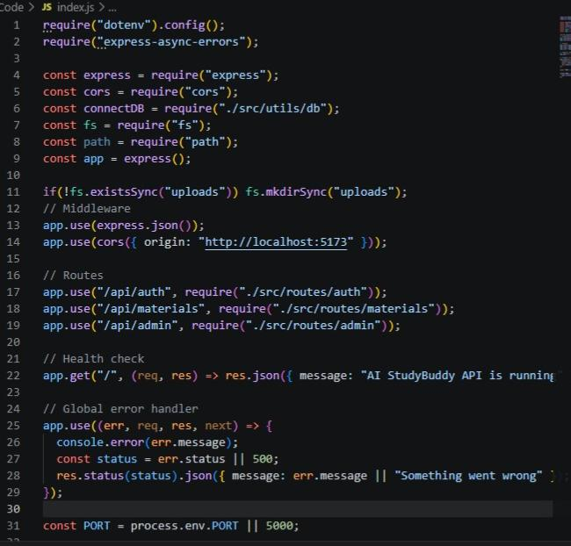
The backend of the AI Study Buddy project is developed using Node.js and Express.js. The index.js file is used to configure and start the backend server. It loads environment variables, initializes Express, enables JSON data processing, and configures CORS for communication with the frontend.
Key Functions:
- Initializes the Express.js server.
- Configures environment variables using .env.
- Enables JSON request handling.
- Configures CORS for frontend communication.
- Connects Authentication, Materials, and Admin API routes.
- Creates the uploads directory for uploaded files.
- Provides an API health-check endpoint.
- Handles errors using a global error handler.
- Runs the server on the configured port, with 5000 as the default port.

11.Output
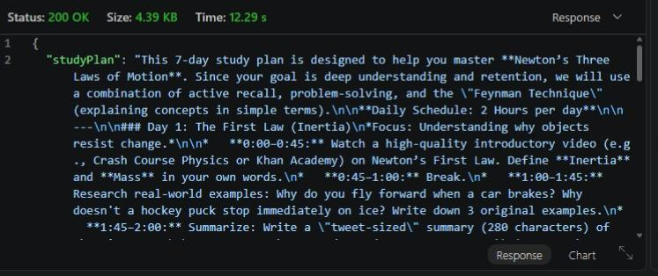

12.Conclusion

The AI Study Buddy project provides an intelligent and user-friendly platform to support students in their learning process. It combines Node.js, Express.js, MongoDB, and Google Gemini AI to provide features such as study material management, AI-generated summaries, flashcards, quizzes, and study plans.

The system also includes JWT-based authentication and secure file handling, making the application reliable and organized. Overall, AI Study Buddy helps students make their learning process more efficient, interactive, and personalized.

Project resources

DEMO VIDEO LINK:https://drive.google.com/file/d/11XqSkv6erMm7vBfypmuoIEjoKd-_vgx5/view?usp=drivesdk

Source Code: code link

